PGSA Sock Fundraising Form
Get your own CU psychology socks!
The Psychology Graduate Student Association has designed one-of-a-kind psychology specific socks to raise funds for future psych graduate student events. These socks are stylish, useful, and will help support your student organization! See below for order information.
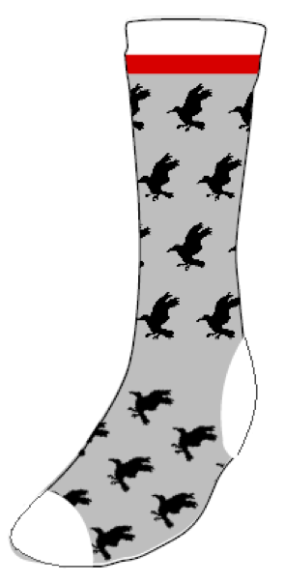
Cost: $20/pair
Sock options:
- Crew sock (athletic-type sock, above the ankle)
- Knee-high sock

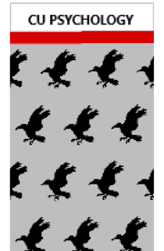

Back View
Side View

To order your pair of socks, please fill out the information below and send this completed form and your $20 payment to Chloe Pedneault (PGSA president) via e-transfer at chloe.pedneault@carleton.ca. You can also contact Chloe to meet in person if you’d prefer to pay in cash. We will contact people when we receive the order with a location in Loeb for pick-up.
Name (first and last):
E-mail address:
Phone number:
How many pairs of crew socks would you like to order?
How many pairs of knee-high socks would you like to order?
What is your shoe size (please indicate male or female with size)?

